**PHY1002 Physics Laboratory**

**Short Report**

|  |  |  |  |
| --- | --- | --- | --- |
| Name: | CHEN, Haopeng | Student ID: | 120090645 |
| Group: | 8 | Date of Experiment: | Oct.19th, 2021 |

**Experiment 1. Centripetal Force**

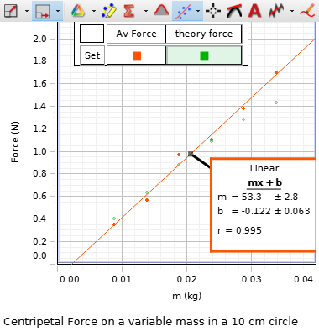1. Plot the centripetal force ($F$) vs. mass ($m$), what is the relationship between them?

Figure 1

The magnitude of centripetal force is a linear function of the mass.

2. Plot the centripetal force ($F$) vs. square of the tangential speed ($v^{2}$), what is the relationship between them?

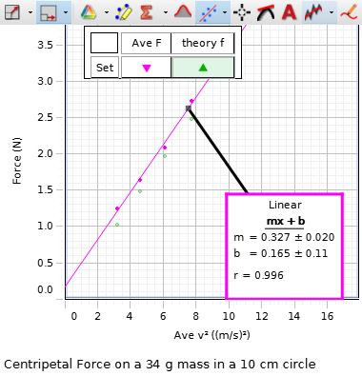

Figure 2

The magnitude of centripetal force is a linear function of the square of the tangential speed.

3. Plot the centripetal force ($F$) vs. the radius of the rotating arm ($r$), what is the relationship between them?

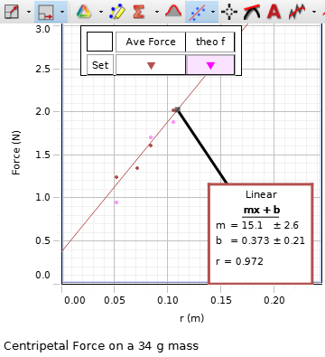

Figure 3

The magnitude of centripetal force is a linear function of the radius of the rotating arm.

4. Can you verify the equation from the theory $F=\frac{mv^{2}}{r}$, why? Does the friction force between the mass and the rotating arm affect your experiment, how?

According to Figure 1, we can conclude $F∝m$ with fixed rotating radius $r$ and angular velocity $ω$. And we configure $F∝v^{2}$ with fixed mass $m$ and fixed rotating radius $r$ in Figure 2. Also, we have $v=ωr$, which means that $F∝ω^{2}$ with $r$ and $m$ fixed. In Figure 3, with fixed $m$ and $ω$, we point out $F∝r$. With the previous result, we can verify that $F=kmω^{2}r=k\frac{mv^{2}}{r}$, where $k$ is the proportional constant. In modern physics, we consider $k=1$, then we verify the theory $F=\frac{mv^{2}}{r}$.

The friction force does affect the experiment. As centripetal force is attained by summarize all force on the object which has the tendency to have linear motion with constant velocity, the friction may come into effect as the resistance to this tendency. So it or its component may be consider part of the centripetal force, which makes the tension, which we consider it as the full of centripetal force, smaller.

Appendix:

Attach the table in Procedure m, Procedure v, and Procedure r. (you should write a clear and detailed caption for each table.)

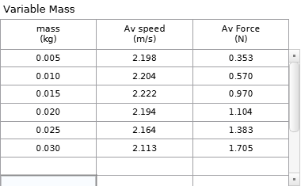

We tied the mass with a string connected to the force censor to count the force. And that mass can be freely moved on a rotating platform. Then we fixed another identical mass on the other side to avoid wobbling. And we start the platform with a higher speed to minimize the friction by putting the mass a correct position. After about 10 seconds, we reduce a little bit the speed and start to collect the data with 60 seconds. Then we add the mass with 5 grams per time and repeat the experiment until it is 30 grams.

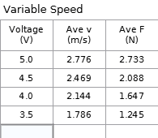

With the previous experiment end, we have mass of 30 grams. We start with the 5.5 volt to the apparatus, to minimize the friction by putting the mass a correct position. Then we reduce to 5.0 volt and collect data with 20 seconds, and we reduce 0.5 per time and repeat the experiment until it is 3.5 volt.

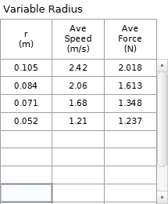

With mass of 30 grams and radius of 105 mm, we start rotating with 5.0 volt to put it correct position and collect data with 4.5 volt in 20 seconds. Then, we try to make radius as 85 mm, 70 mm and 50 mm to repeat the experiment.

_____________________________________________________________________

--- End of Laboratory Report ---

**Notes:**

* **Submit soft copies online.**
* **No further modification allowed after deadline.**
* **Please don’t exceed 2 pages** **(exclude appendix), with normal margin and 1.0 line space.**
* **No figure is required if not specified.**